**CAESAR BEACH**

**PRICE LIST**

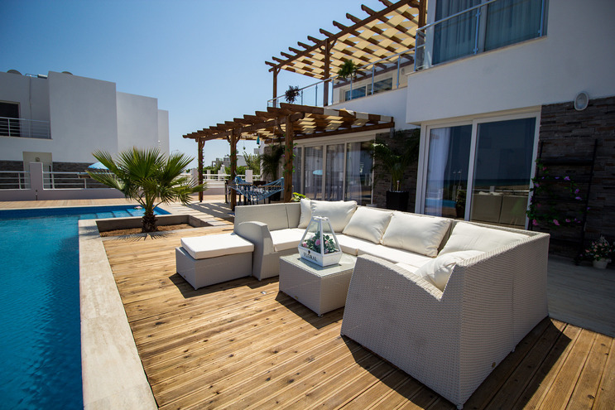

Bedroom: S/1/2/3

Penthouses

Bathroom: 1/2

**From £30,000**



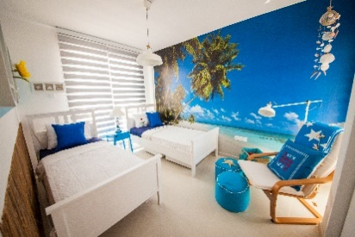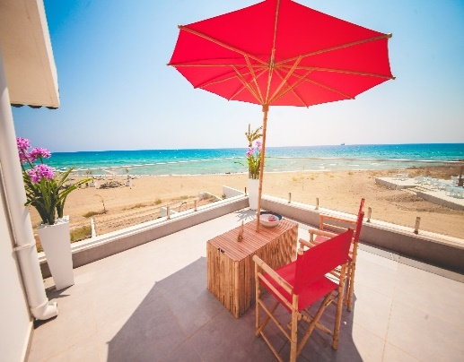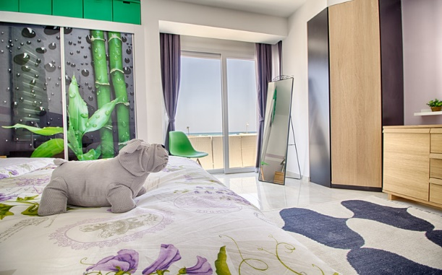

“Caesar Beach” is a modern residential complex, designed and developed by Afik Group. Villas, apartments, semi-detached villas located by the Sea and well-equipped sandy beach with different types of watersports  will touch feelings of any demanding customer. Intriguing  breathtaking views and unique atmosphere will help to make decision and select accommodation that will answer the requirements of potential owners.

 Advantages of “Caesar Beach”:

* Proximity to the sea.
* Ready facilities of the complex – restaurant, sports grounds, and children play grounds.
* Availability of BBQ areas, gym, swimming pool and sauna.
* Same style of all buildings that creates harmony of nature and architecture.

**Standard Specifications:**

5-year structural guarantee

Reinforced concrete frame construction

Climate and Water Insulation Roofing

1/2 elevators in each building

PVC Double glazed windows

Parking space

Sewage system

Water heating system

Interior Doors (including locks and handles)

Entrance Door (including lock and handle)

Internal walls – painted

Internal flooring - ceramic

Electrical / TV/ Internet points

**Kitchen:**

Work top with choice of colors

Base units and cupboards

Stainless steel sink

Ceramic wall tiling above base units

All plumbing included (piping / taps)

**Bathroom:**

Toilet unit

Sink and mirror

Shower

Walls and flooring: ceramic tiling

|  |  |
| --- | --- |
| **MAINTENANCE FEE (annual), starting from key handover**  **ПЛАТА ЗА ОБСЛУЖИВАНИЕ (в год) начиная с даты получения ключей** | |
| **Bedrooms / Комнаты** | **CAESAR BEACH/ Бич** |
| Studio / Студио | 552 GBP |
| 1 | 620 GBP |
| 2-3 | 690 GBP |
| Villa / Вилла | 480 GBP |
| Semi-Detached / Таунхаус | 720 GBP |

|  |  |  |
| --- | --- | --- |
| **EXTRA FEE (one-time payment)** | | |
| **ДОПОЛНИТЕЛЬНЫЕ ПЛАТЕЖИ (разовые расходы)** | | |
| VAT **/ НДС** | 5 % of sales price | Can be paid within 1 year after handover  **В течении 1 года после получения ключей** |
| Utility connection / **Подключение к коммуникациям** | Connection of water and electricity  **Подключение воды и электричества** | |
| CAESAR BEACH APARTMENTS  **КВАРТИРЫ** | 1500-GBP | Can be paid within 1 year  **В течении 1 года после получения ключей** |
| CAESAR BEACH SEM DETACHED VILLA  **ТАУНХАУСЫ** | 2000-GBP | Can be paid within 1 year  **В течении 1 года после получения ключей** |
| CAESAR BEACH VILLA  **ВИЛЛЫ** | 3000-GBP | Can be paid within 1 year  **В течении 1 года после получения ключей** |
| STUMP DUTY  **ГЕРБОВЫЙ СБОР** | 0.5% | With signing contract/ first installment  **До/при подписании контракта** |
| SOLICITOR FEE (registration contract in TAPU, purchase permission)  **Услуги адвоката (регистрация договора в Земельном комитете, разрешение на покупку)** | 1200-GBP | With signing contract/ first installment / Can choose own solicitor as well  **До/при подписании контракта** |
| TAX for transfer Title Deeds  **Налог на перевод Титулов** | 3% | Can be paid/or no/ after 100% paid in complete and when the project is finalized  **Не обязательный налог, уплачивается после 100% оплаты и завершения проекта** |

[Caesar Beach Price](http://pricelist.afikgroup.com/caesar-beach.html)

|  |  |  |  |  |  |  |  |
| --- | --- | --- | --- | --- | --- | --- | --- |
| **PLOT** | **TYPE** | **PLOT SIZE  M2** | **DESCRIPTION** | **POSITION** | **BEDROOMS** | **BUILD AREA M2** | **PRICE GBP** |
| **A** | Semi Detached Villa | 550 | M3 | Premiere- with pool | 2 | 177 | £650,000 |
| **4** | Detached Villa | 840 | M3 | Premiere- with pool | 3 | 160 | £420,000 |

**TYPE F APARTMENTS**

|  |  |  |  |  |  |  |
| --- | --- | --- | --- | --- | --- | --- |
| **Floor** | **Type F** | **Bedrooms** | **Covered gross area(sqm)** | **Balcony ( sqm)** | **Position** | **Price in GBP** |
| gr | A-4 | 2 | 73 | 13 | Ground Center 1 | 90.000 GBP |
| gr | A-5 | 2 | 73 | 13 | Ground Center 2 | 90.000 GBP |
| 1st | A-7 | 1 | 50 | 11 | Top Center 1 | reserved |
| 1st | A-9 | 1 | 50 | 11 | Top Center 3 | reserved |
| gr | A-10 | 2 | 73 | 13 | Ground Right 1 | reserved |
| gr | A-11 | 2 | 73 | 13 | Ground Right 2 | reserved |
| 1st | A-15 | 1 | 50 | 11 | Top Right 3 | reserved |